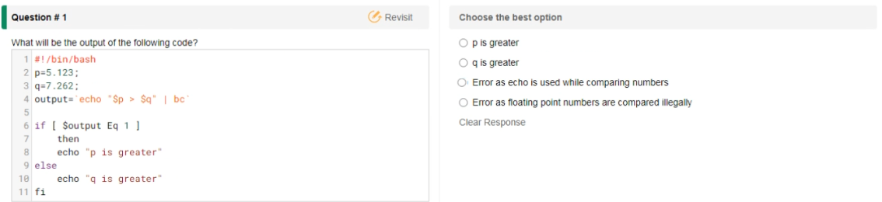

Ans: q is greater

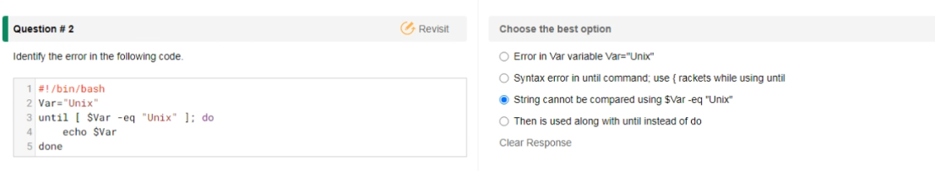

Ans: Syntax error in until command; use {racket while using until

Displayed error like this:

Script2.sh: line 3: [: Unix: integer expression expected

Unix

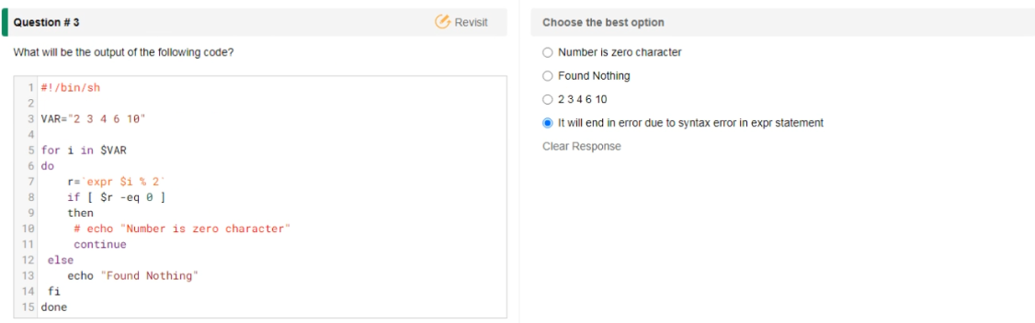

Ans: Found Nothing

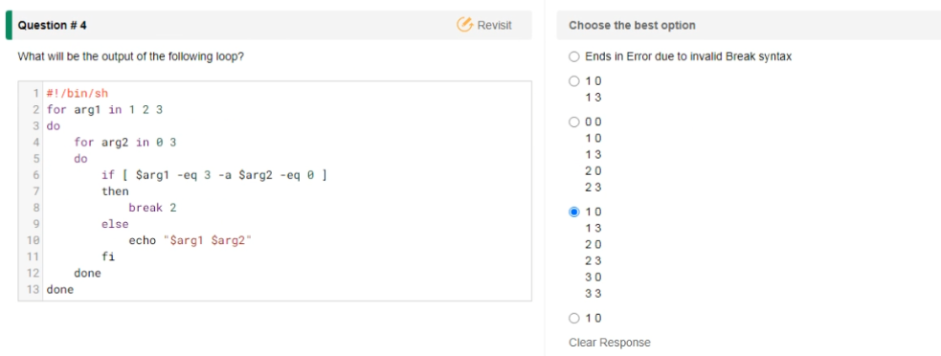

Ans:

1 0

1 3

2 0

2 3

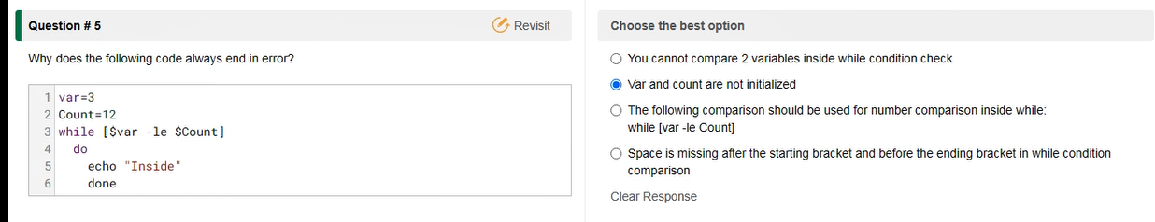

Ans: You can not compare 2 variables inside while condition check

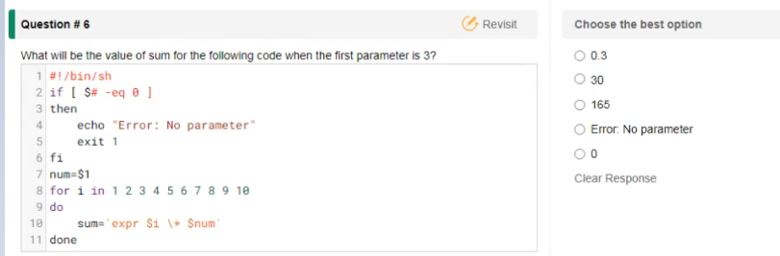

Ans: Error: No parameter

Networking:

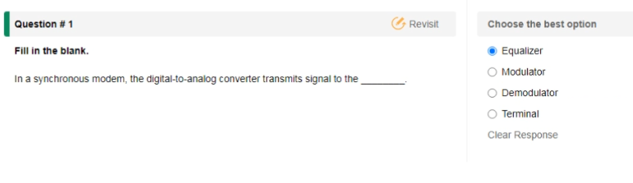

Ans: Equalizer

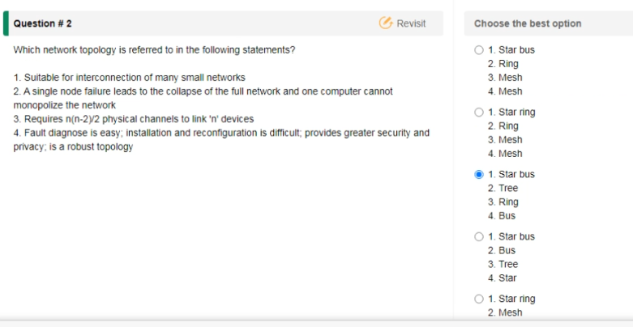

Which network topology is referred to in the following statements?

1.Suitable for interconnection of many small networks - Bus

2.A single node failure leads to the collapse of the full network and one computer cannnot monopolize the network - Ring

3. Requires n(n-2)/2 physical channels to link 'n' devices - Mesh

4.Fault diagnose is easy; installation and reconfiguration is difficult; provides greater security and privacy; is a robust topology - Mesh

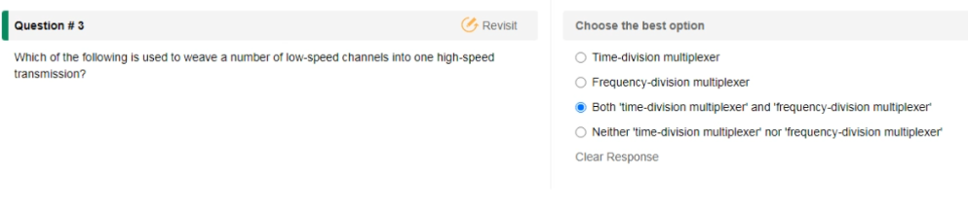

Ans: Time-division multiplexer

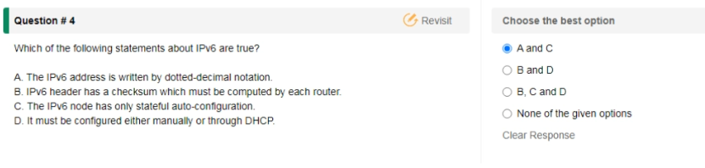

Ans: None of the given options

The IPV6 address is written by dotted-decimal notation. - False

IPV6 header has a checksum which must be computed by each router - False

The IPV6 node has only stateful auto-configuration - False

It much be configured either manually or through DHCP - False

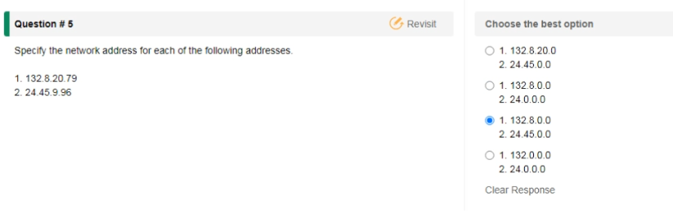

Ans: 132.8.20.0 and 24.45.0.0

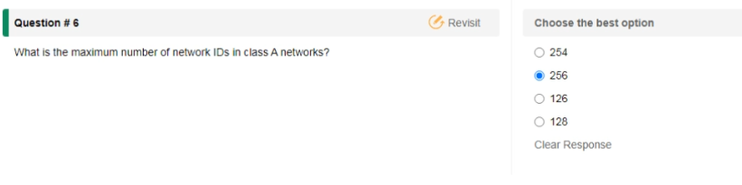

Ans: 126 (Class A 27 – 2 = 126, Total Network ID bits 8)

(Class B 214 – 2 = 16384, Total Network ID bits 16)

(Class A 221 – 2 = 2097152, Total Network ID bits 24)

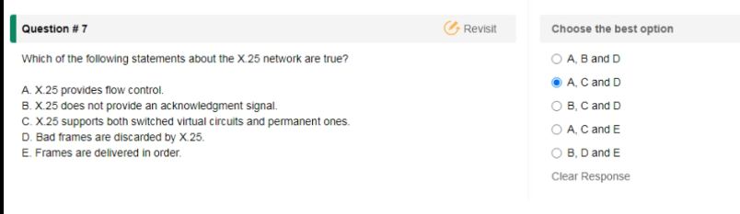

Looks Ans is A,B and D – C is Ture or False doubt.

X.25 provides flow control - True

X.25 does not provide an acknowledgement - True

X.25 supports both switch virtual circuits and permanent ones - True

Bad frames are discarded by X.25 - True

Frames are delivered in order - False

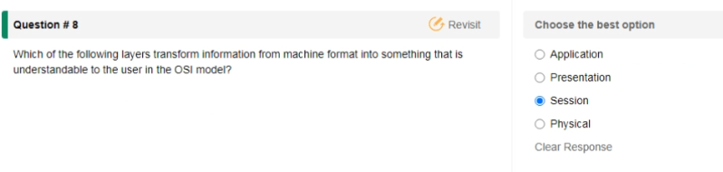

Ans: Presentation layer.

AWS:

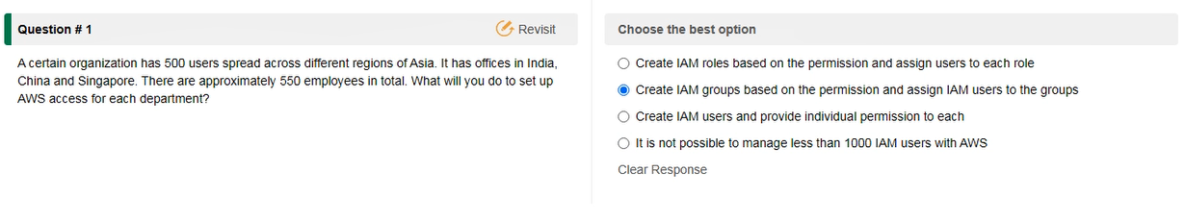

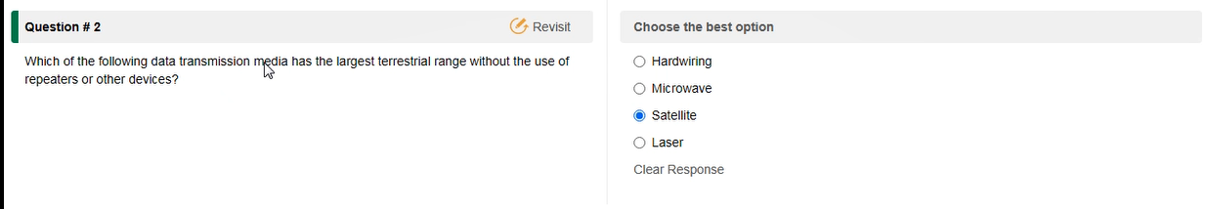

Ans: Satellite

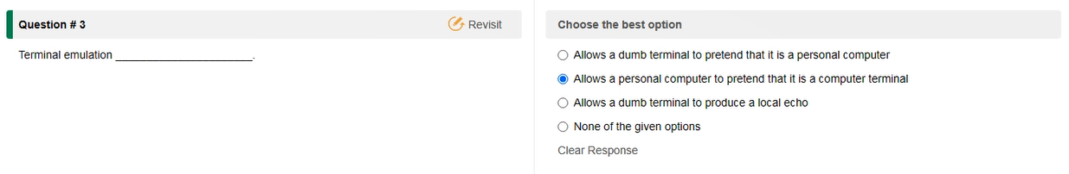

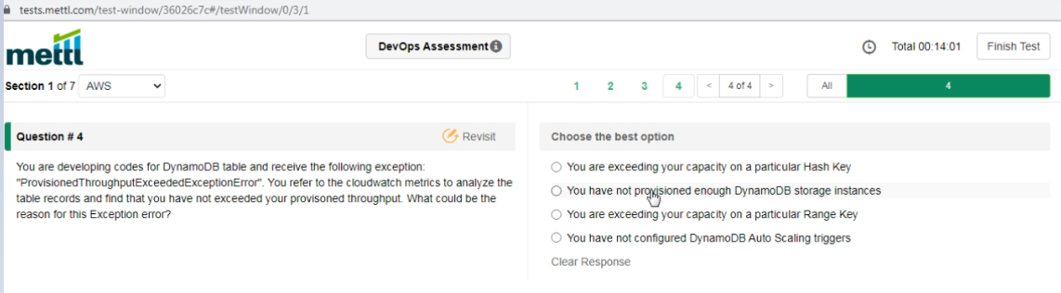

Ans: You are exceeding your capacity on a particular Hash Key

Jenkins

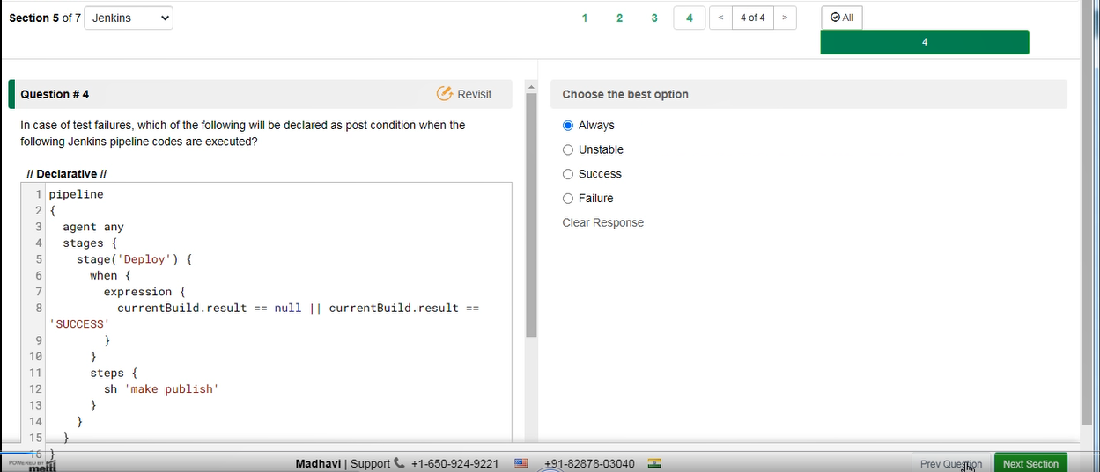

Failure

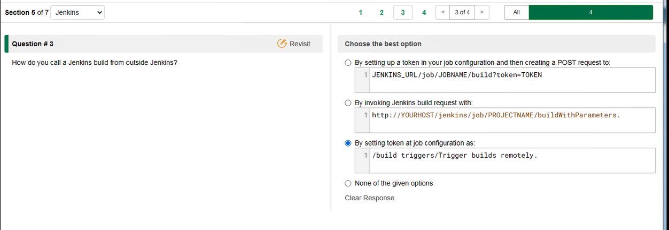

http://YOURHOST/jenkins/job/PROJECTNAME/build

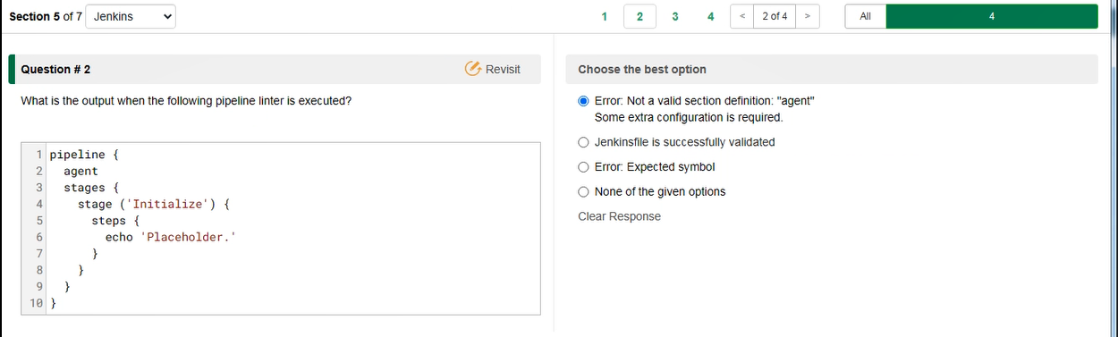

Error: Not a valid section defined: “agent” Some extra configuration is required.

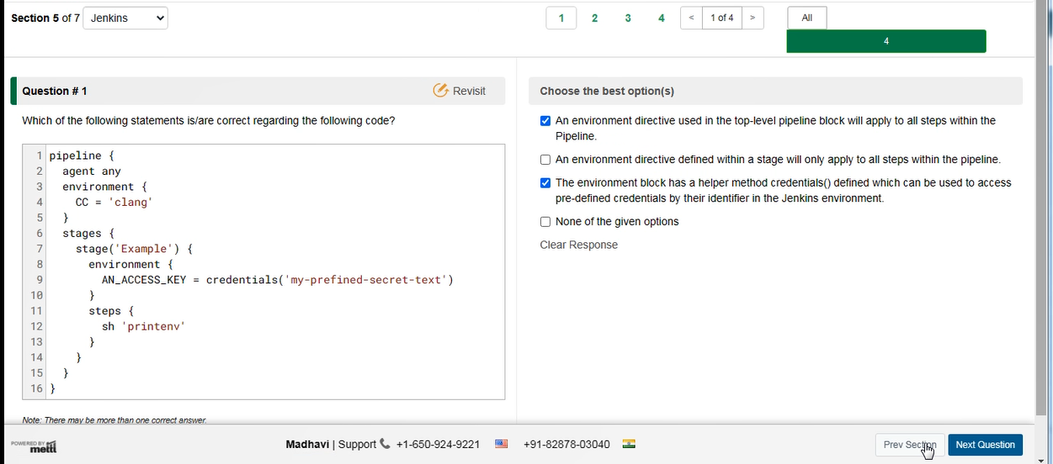

GIT

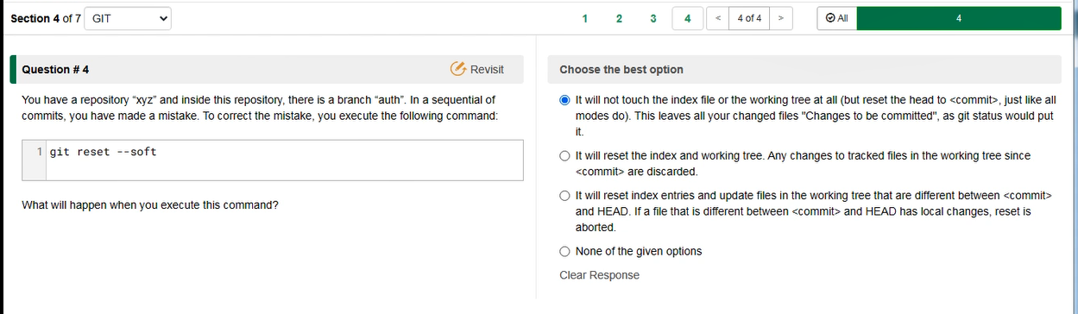

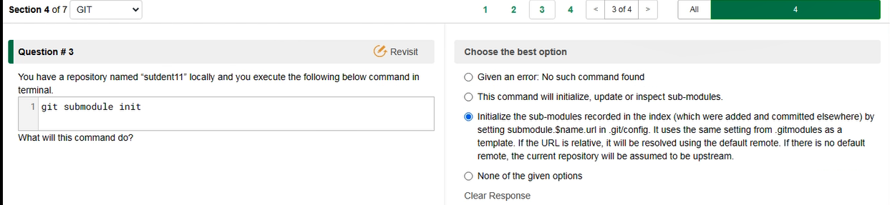

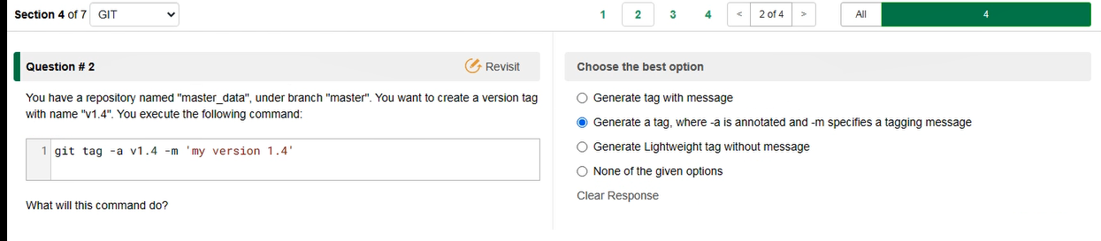

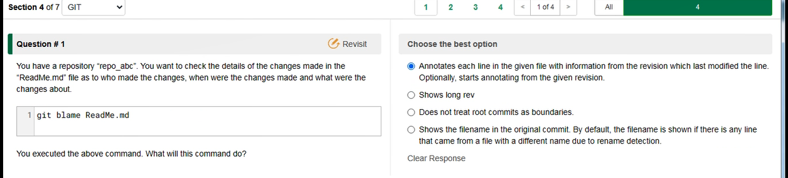

Selected option is correct.

Docker

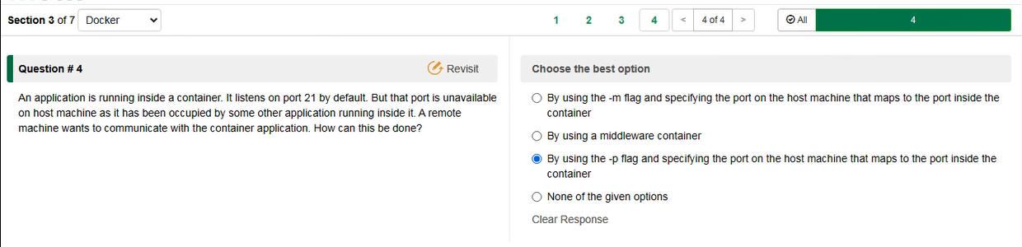

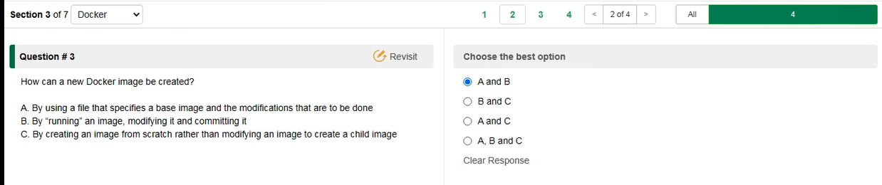

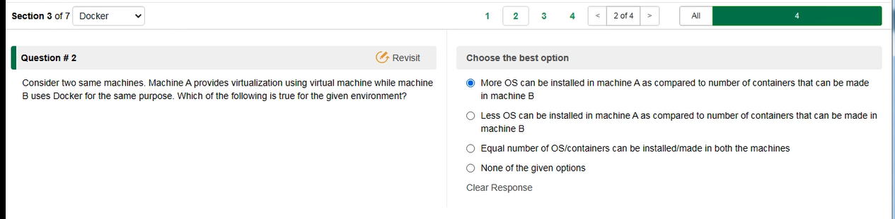

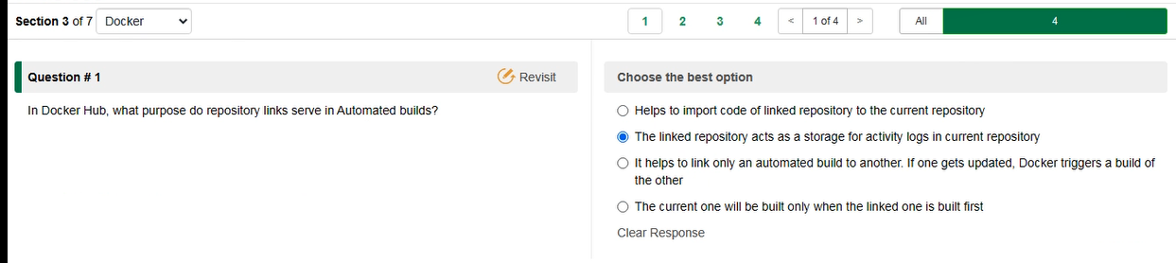

Ans: C

DevOps:

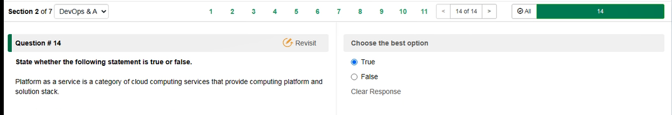

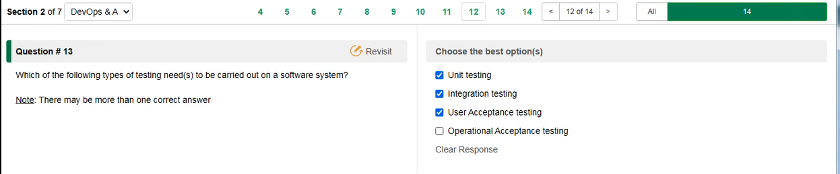

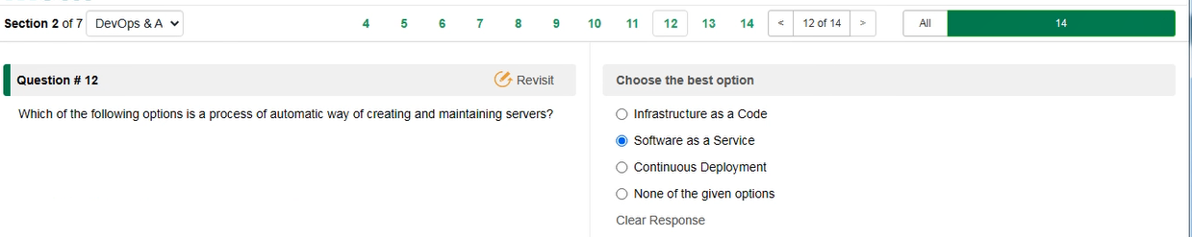

Ans: Infrastructure as code

